Data Collection and Preprocessing Phase

Date | 2 February 2026
Team ID | LTVIP2026TMIDS52507
Project Title | IntelliSQL: Intelligent SQL Querying with  LLMs Using Gemini Pro
Maximum Marks | 6 Marks

Data Exploration and Preprocessing Report
Unlike traditional machine learning projects that rely on static datasets, IntelliSQL operates on realtime, user-provided natural language queries. Data exploration and preprocessing focus on validating user input, handling dynamic text, and structuring prompts suitable for large language model processing. Python is used to preprocess and format user queries before forwarding them to the Gemini Pro model, ensuring accurate, context-aware SQL generation and reliable database query execution.

Data Overview

Section | Description
Data Type | Textual data (user-provided natural language queries)
Data Source | Real-time user input collected through the Streamlit web interface
Data Format | Plain text
Data Size | Dynamic (varies based on user queries)
Nature of Data | Natural language text intended for SQL query generation

Descriptive Statistics

Aspect | Description
Statistical Measures | Not applicable, as the project does not rely on a fixed numerical dataset
Text Characteristics | Variable-length natural language queries provided by users
Distribution | Dynamic and dependent on user input, query complexity, and language usage

Univariate Analysis

Analysis | Description
Input Text Length | 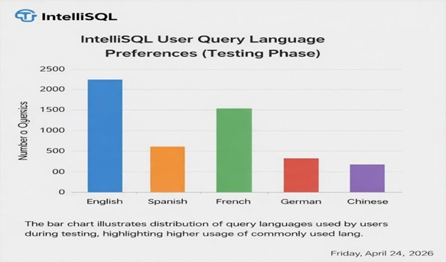  Analysis based on individual text input length
Language Type | Single-language input per request
Character Distribution | Alphabetic, numeric, and special characters

Bivariate Analysis
Analysis | Description
Source vs Target Language | Relationship between selected source and target databases
Text Length vs Response  Time | 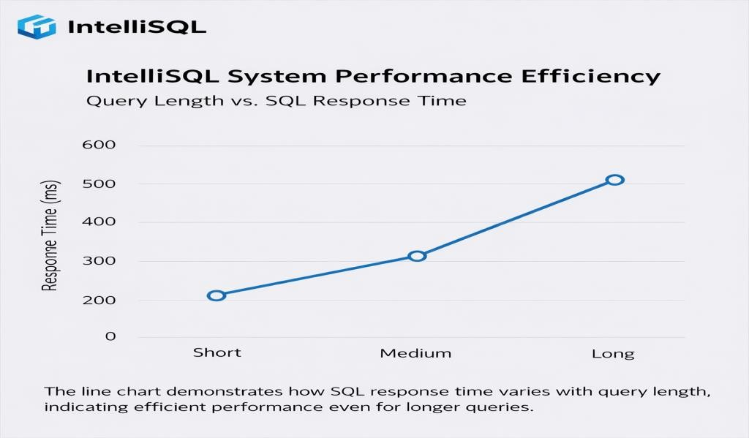  Longer input text may slightly increase processing time

Multivariate Analysis

Analysis | Description
Text + Source Language +  Target  Language | Combined influence on translation accuracy and response quality
User Input Patterns | Variation in usage across different language combinations  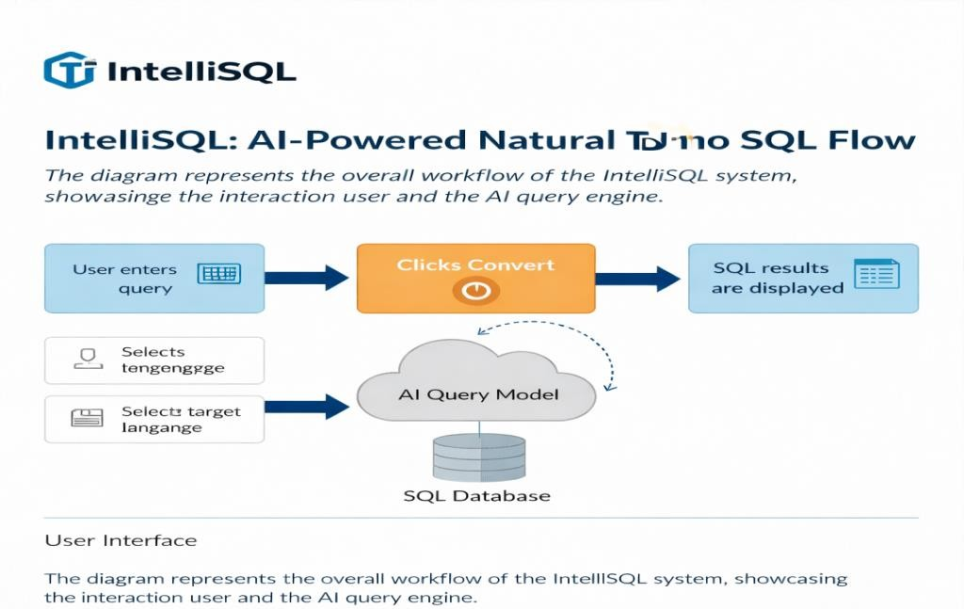

Outliers and Anomalies

Category | Description
Outliers | Extremely long text inputs
Anomalies | Unsupported characters or empty inputs
Handling Method | 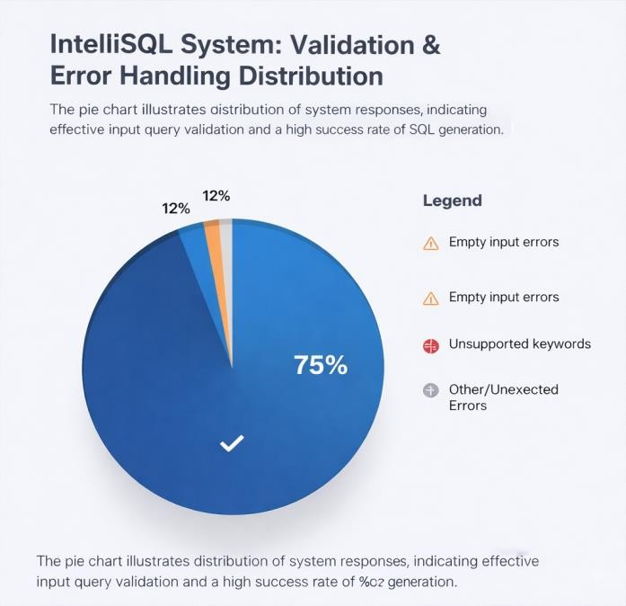  Input validation and warning messages in UI

Data Preprocessing Steps

Step | Description
Loading Data | Text is captured directly from the Streamlit text input field. No external dataset loading is required as the system operates on real-time user input.
Handling Missing  Data | Empty or null input is handled through input validation. Users are prompted to provide valid text before the translation process begins.
Data  Transformation | Text normalization is performed by trimming extra spaces and formatting the input into a structured prompt suitable for the Gemini Pro model. Encoding is handled internally by the model.
Feature  Engineering | Source language and target language selections are treated as contextual parameters. Prompt engineering techniques are applied to improve translation accuracy and contextual relevance.
Save Processed  Data | Processed data is not stored permanently. Translations are generated and displayed to the user in real time without persistent storage.

